Multiple-choice section – choose the correct answer

Question 1 [3.1]

What is the expansion of ?

A  B  C  D 

Question 2 [3.1]

Expanded, the expression  is:

A  B  C  D 

Question 3 [3.2]

Fully factorised,  is:

A  B  C  D 

Question 4 [3.4]

The dilation factor of  is:

A  B 1 C 2 D 4

Question 5 [3.4]

The graph of  is dilated by a factor of 2, shifted 3 units right and 1 unit up. The equation is:

A y = 3(x – 2)2 + 1 B y = 2(x – 1)2 + 3 C y = 2(x – 3)2 + 1 D y = 2(x + 1)2 + 1

Question 6 [3.5]

In factorised form,  is:

A  B  C  D 

Question 7 [3.6]

When k2 – 25 is factorised, it is:

A (k + 25)(k – 1) B (k + 5)(k – 5) C (k2 + 5)(k2 – 5) D (k – 5)(k – 5)

Question 8 [3.7]

÷ simplifies to:

A  B 1 C 5(p + 3) D 

Multiple-choice total marks: __ / 8

Short answer section

Question 9 2 marks [3.2, 3.5]

Use words from the list below to complete the following sentences.

factorising algebraic fractions perfect squares monic

difference of two squares completing the square quadratic trinomial binomial product

(a) ______________ involves taking out the highest common factor of terms.

(b) A ________________________________ consists of three terms whose highest power of the variable is 2.

Question 10 2 marks [3.2]

What is the relationship between factorising and expanding?

Question 11 2 marks [3.1]

Expand and simplify.

Question 12 4 marks [3.1]

(a) Give the expression for the perimeter of the triangle in simplest form.

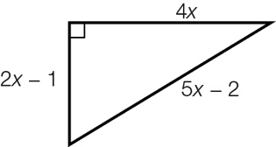

(b) Write the area of the triangle in expanded form.

Question 13 2 marks [3.1]

The length and width of a rectangle is  and respectively. Write the area of the rectangle in expanded form.

Question 14 3 marks [3.2]

Jerome wishes to factorise the expression .

(a) What highest common factor must Jerome use?

(b) What factorised expression will he obtain?

Question 15 4 marks [3.2]

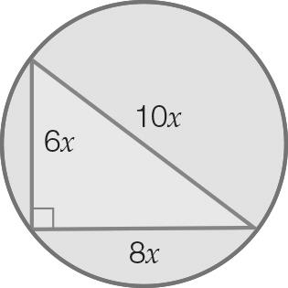

The hypotenuse of the triangle is also the diameter of the circle.

(a) Write an expression for the area of the whole circle. (Hint: The area of a circle is given by area = πr2.)

(b) Write an expression for the area of the triangle. (Hint: The area of a triangle is × base × height.)

(c) Using your answers for (a) and (b), write an expression for the area of the circle that is not in the triangle.

(d) Factorise your answer to (c).

Question 16 3 marks [3.4]

Explain the transformations required to obtain the graphs of  from 

Question 17 3 marks [3.4]

Use transformations to sketch the graph of y = 3(x + 2)2 + 1.

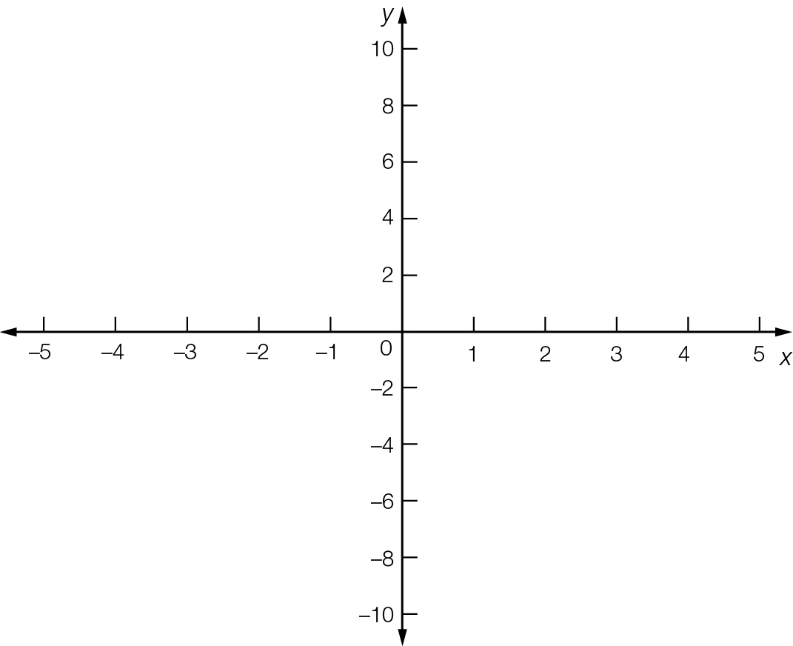

Question 18 3 marks [3.6]

Complete the missing parts of the calculation.

45g2h2 – 5c2

= 5(___g2h2 − c2)  
= 5((___gh)2 − c2)  
= 5(___gh − c)(___gh __ c)

Question 19 3 marks [3.7]

By first factorising the numerator, simplify .

Question 20 3 marks [3.7]

Simplify by writing the expression with a common denominator.

Short answer total:_________/34

Extended answer section

Question 21 5 marks [3.1]

Let a, b and c be three numbers with  and.

(a) Express b and c in terms of a.

(b) Write the product of the three numbers in terms of a.

(c) Expand and simplify the expression in (b).

Question 22 5 marks [3.5, 3.6]

(a) Factorise using the cross method.

(b) Write in the form (___)2.

(c) Hence factorise 

Question 23 6 marks [3.5]

The height h m of a ball above the ground at time t seconds after it has been thrown from a roof is given by .

(a) How high is the ball above the ground when it is first thrown (that is, when t = 0)?

(b) Factorise .

(c) State the time it takes for the ball to reach the ground (that is, what positive value of t makes h = 0?).

Question 24 5 marks [3.1, 3.2]

The diagram shows the floor plan of a room; the lengths are in metres.

(a) Label each unlabelled side with expressions for their lengths.

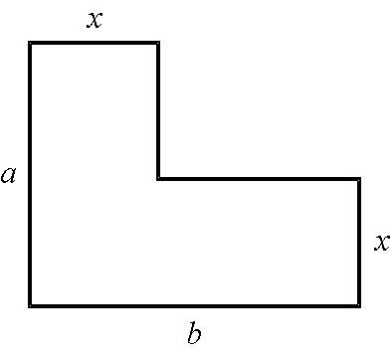

(b) Find an expression for the area of the carpet by adding two rectangular areas. Write your answer in expanded form.

(c) Find an expression for the area of the carpet by subtracting the area of the smaller rectangle C from the area of the large rectangle. Write your answer in expanded form.

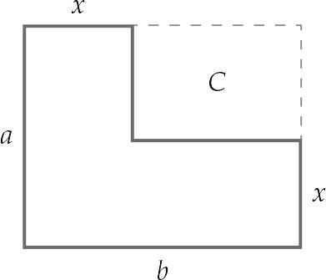

Extended answer total:_________/21

TOTAL test results: ___ / 63